Name : Tushar Pathak
RegNumber : 230905396
Roll Number: B48

Lab 4: Collective Communications and Error Handling in MPI

Q1)Write a MPI program using N processes to find 1! +2! +.....+N!. Use scan. Also, handle different errors using error handling routines.

Code:
#include <mpi.h>
#include <stdio.h>
#include <stdlib.h>

int factorial(int n) {
int f = 1;
for (int i = 1; i <= n; i++)
f *= i;
return f;
}

int main(int argc, char *argv[]) {
int rank, size, fact, scan_sum;
int err;
char err_string[MPI_MAX_ERROR_STRING];
int err_len;

MPI_Init(&argc, &argv);

err = MPI_Comm_rank(MPI_COMM_WORLD, &rank);
if (err != MPI_SUCCESS) {
MPI_Error_string(err, err_string, &err_len);
printf("MPI_Comm_rank error: %s\n", err_string);
MPI_Abort(MPI_COMM_WORLD, err);
}

MPI_Comm_size(MPI_COMM_WORLD, &size);
fact = factorial(rank + 1);

err = MPI_Scan(&fact, &scan_sum, 1, MPI_INT, MPI_SUM, MPI_COMM_WORLD);
if (err != MPI_SUCCESS) {
MPI_Error_string(err, err_string, &err_len);
printf("MPI_Scan error: %s\n", err_string);
MPI_Abort(MPI_COMM_WORLD, err);
}
if (rank == size - 1) {
printf("Sum of factorials from 1! to %d! = %d\n", size, scan_sum);
}

MPI_Finalize();
}

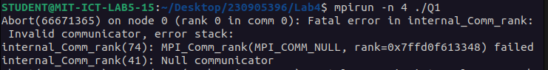
Output :

Q2)Write a MPI program to read a 3 X 3 matrix. Enter an element to be searched in the root process. Find the number of occurrences of this element in the matrix using three processes.
Code:
#include <mpi.h>
#include <stdio.h>

int main(int argc, char *argv[]) {
int rank, size;
int matrix[3][3];
int key, count = 0, total_count;

MPI_Init(&argc, &argv);
MPI_Comm_rank(MPI_COMM_WORLD, &rank);
MPI_Comm_size(MPI_COMM_WORLD, &size);

if (size != 3) {
if (rank == 0)
printf("Run with exactly 3 processes\n");
MPI_Finalize();
return 0;
}

if (rank == 0) {
printf("Enter 3x3 matrix:\n");
for (int i = 0; i < 3; i++)
for (int j = 0; j < 3; j++)
scanf("%d", &matrix[i][j]);

printf("Enter element to search: ");
scanf("%d", &key);
}

MPI_Bcast(matrix, 9, MPI_INT, 0, MPI_COMM_WORLD);
MPI_Bcast(&key, 1, MPI_INT, 0, MPI_COMM_WORLD);

for (int j = 0; j < 3; j++) {
if (matrix[rank][j] == key)
count++;
}

MPI_Reduce(&count, &total_count, 1, MPI_INT, MPI_SUM, 0, MPI_COMM_WORLD);

if (rank == 0)
printf("Number of occurrences = %d\n", total_count);

MPI_Finalize();
}

Output:
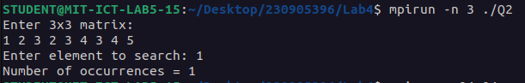

Q3)Write a MPI program to read 4 X 4 matrix and display the following output using four
processes.
I/p matrix: 1 2 3 4 O/p matrix: 1 2 3 4
1 2 3 1 2 4 6 5
1 1 1 1 3 5 7 6
2 1 2 1 5 6 9 7
Code:
#include <stdio.h>
#include <mpi.h>

int main(int argc, char *argv[]) {
int rank, size;
int matrix[4][4];
int row[4], scan_row[4];
int result[4][4];

MPI_Init(&argc, &argv);
MPI_Comm_rank(MPI_COMM_WORLD, &rank);
MPI_Comm_size(MPI_COMM_WORLD, &size);

if (size != 4) {
if (rank == 0)
printf("Run with exactly 4 processes.\n");
MPI_Finalize();
return 0;
}

if (rank == 0) {
printf("Enter 4x4 matrix:\n");
for (int i = 0; i < 4; i++)
for (int j = 0; j < 4; j++)
scanf("%d", &matrix[i][j]);
}

/* Scatter one row to each process */
MPI_Scatter(matrix, 4, MPI_INT, row, 4, MPI_INT, 0, MPI_COMM_WORLD);

/* Cumulative column-wise sum */
MPI_Scan(row, scan_row, 4, MPI_INT, MPI_SUM, MPI_COMM_WORLD);

/* Gather the result matrix */
MPI_Gather(scan_row, 4, MPI_INT, result, 4, MPI_INT, 0, MPI_COMM_WORLD);

if (rank == 0) {
printf("Output Matrix:\n");
for (int i = 0; i < 4; i++) {
for (int j = 0; j < 4; j++)
printf("%d ", result[i][j]);
printf("\n");
}
}

MPI_Finalize();
return 0;
}

Output:
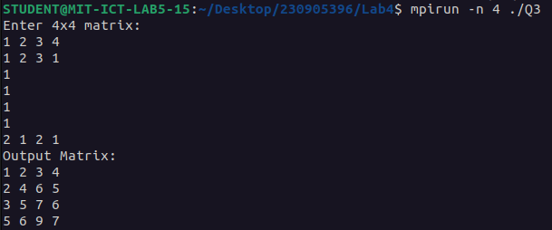

Q4)Write a MPI program to read a word of length N. Using N processes including the root get output word with the pattern as shown in example. Display the resultant output word in the
root.
Example: Input: PCAP
Output: PCCAAAPPPP

Code:
#include <stdio.h>
#include <string.h>
#include <mpi.h>

int main(int argc, char *argv[]) {
int rank, size;
char word[100], ch;
char local[100], result[500] = "";

MPI_Init(&argc, &argv);
MPI_Comm_rank(MPI_COMM_WORLD, &rank);
MPI_Comm_size(MPI_COMM_WORLD, &size);

if (rank == 0) {
printf("Enter word: ");
scanf("%s", word);
}

MPI_Scatter(word, 1, MPI_CHAR, &ch, 1, MPI_CHAR, 0, MPI_COMM_WORLD);

int k = 0;
for (int i = 0; i <= rank; i++)
local[k++] = ch;
local[k] = '\0';

MPI_Gather(local, 100, MPI_CHAR, result, 100, MPI_CHAR, 0, MPI_COMM_WORLD);

if (rank == 0) {
printf("Output: ");
for (int i = 0; i < size; i++)
printf("%s", result + i * 100);
printf("\n");
}

MPI_Finalize();
return 0;
}
Output:

